Save this file in the Word Startup folder. In Windows XP the default location for that folder is
C:\Documents and Settings\[User Name]\Application Data\Microsoft\Word\STARTUP
In Windows Vista and Windows 7, 8 and 8.1, it is
C:\Users\[User Name]\AppData\Roaming\Microsoft\Word\STARTUP
When you have done that, the tab shown below will be added to the Ribbon:
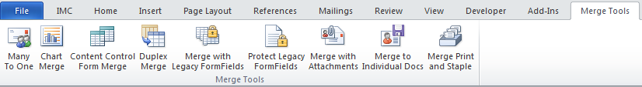
If this add-in does not do exactly what you require, I offer a service to create customized versions.
You can contact me with your requirements at dkr@mvps.org

